|  |  |  |  |  |
| --- | --- | --- | --- | --- |
| Description: logo baru PMTG | | | | |
| **CODE / COURSE** | **DFP30243-OBJECT ORIENTED PROGRAMMING** | **LABORATORY TASK** | **1 ~~/ 2 / 3 / 4~~** | |
| **PROGRAM / CLASS** |  | **DURATION** | **2 HOURS** | |
| **STUDENT’S NAME** | **1.**  **2.** | **CLO** | **1P** |  |
|  |  |
| **REG. NO.** |  | **TOTAL MARKS** | **/75** | |
| **LECTURER’S NAME** | **PN. SHARIZAN BINTI ABDUL JAMIL CIK NURAINI BINTI SHAMSAIMON** |

**CLO1**: Construct Object Oriented Programming concept and exception handling in Java programming (P4, PLO3)

**Learning Outcomes**: Upon completion this lab, students should be able to:

1. construct variables, operators and input/output streams.
2. construct branching statement and arrays.

**INSTRUCTION: Answer all questions.**

QUESTION 1

The program in Figure A1 has logic errors. Rewrite the program to produce correct results.

*If the input is 39.0, the output should be “You get a high fever. Go to hospital immediately”*

*If the input is 37.5, the output should be “You get a fever. Go to clinic”*

*If the input is 36.3, the output should be “You are ok”*

*If the input is less than 35.0, the output should be “You get a hypothermia. Go to hospital immediately”*

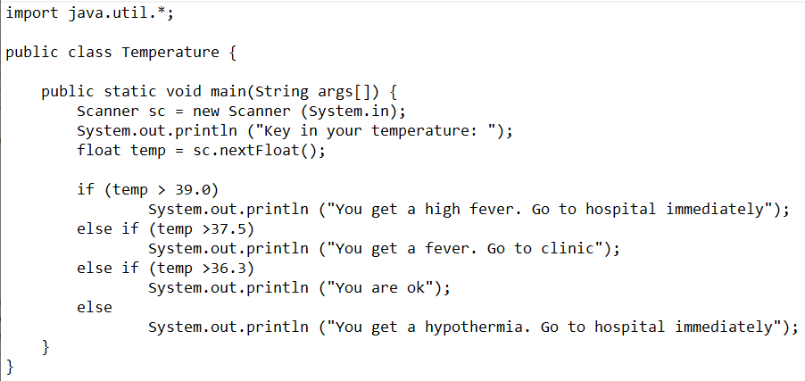

Figure A1

ANSWER:

1. Proceed the program above and get the output of the program for input 39.0
2. SOURCE CODE

*snip and paste your code here. (Make sure it is snipped from your text editor/java platform). Refer Appendix 1 for an example.

1. OUTPUT
2. if input = 34.0
3. if input = 38.0
4. if input = 40.0

*snip and paste your output here. (Make sure it is from your command prompt/java platform). Refer Appendix 1 for an example.

QUESTION 2

Write a program to display BMI category as shown in Table A1. The calculation of BMI is based on the formula given: resultBMI = Weight in Kg / (Height in Meters * Height in Meters). Use Buffered Reader Class to get an input weight and height from user.

Table A1

|  |  |
| --- | --- |
| Category | BMI Range |
| Underweight | <18.5 |
| Normal | 18.5 - 24.9 |
| Overweight | 25 - 30 |
| Obese | >30 |

ANSWER:

1. SOURCE CODE

*snip and paste your code here. (Make sure it is snipped from your text editor/java platform). Refer Appendix 1 for an example.

1. OUTPUT

*snip and paste your output here. (Make sure it is from your command prompt/java platform). Refer Appendix 1 for an example.

QUESTION 3

Reproduce the program in Figure A2 by using for loop so that the program can accept three (3) input of vowels from user and display all the contents in array.

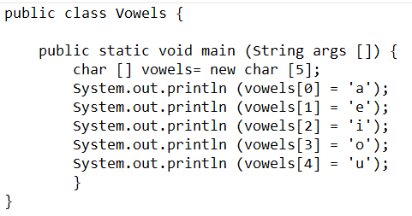

Figure A2

ANSWER:

1. SOURCE CODE

*snip and paste your code here. (Make sure it is snipped from your text editor/java platform). Refer Appendix 1 for an example.

1. OUTPUT

*snip and paste your output here. (Make sure it is from your command prompt/java platform). Refer Appendix 1 for an example.

***Appendix 1***

**Example of source code:**

1. If you use Java platform to write the source code

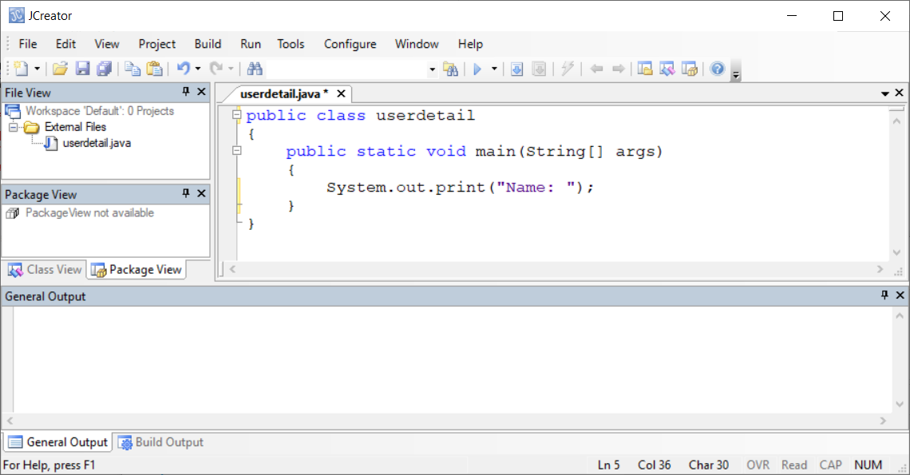

1. If you use text editor to write the source code

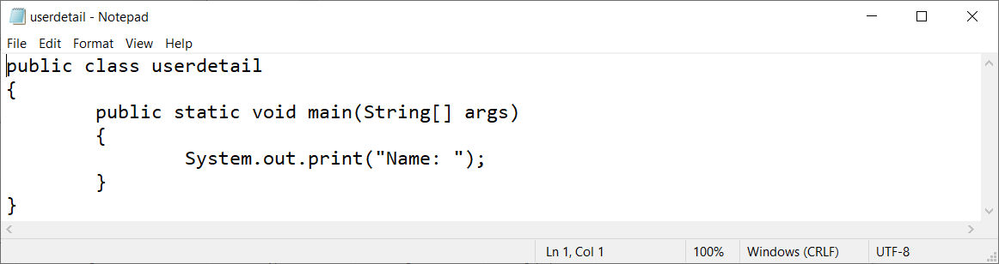

**Example of output:**

1. If you use Java platform to compile and execute

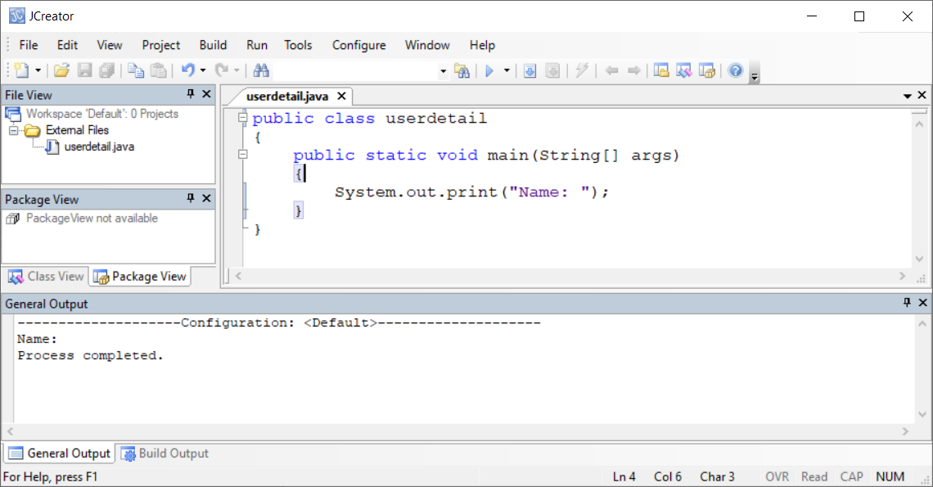

1. If you use Command Prompt to compile and execute

